Social Activities

The Social Chair is responsible for arranging the Division Dinner at each National ACS meeting and for coordinating with the Division Chair on other social events, such as Executive Committee dinners and refreshments for poster sessions.
The job entails finding a restaurant in the host city that has a distinctive cuisine, a private dining hall that can accommodate 40-60 people, and that can provide a fixed menu at a reasonable price. If a special gourmet meal can be provided within these constraints, so much the better.
A letter detailing the requirements is sent to the restaurant (copy attached), and a confirming letter of commitment or booking must be obtained. This letter, along with a form provided by ACS (copy attached), must be on file by the deadline set by ACS, generally four months ahead of the meeting so that a notice will appear in the final program in C&E News.
The Social Chair also informs the editor of EnvirofACS and the Division Chair of the arrangements, in time for publication in the newsletter.
The Social Chair makes any needed transportation arrangements, notifies the Division Treasurer of any advance payment to the restaurant, and determines the number of tickets to be printed by ACS for the dinner. Allowances are made for guest tickets to awardees, according to requests from the Awards Chair and the Division Chair.
The Social Chair arranges for notification of a final count (± 5-10%) of reservations for the restaurant, 12-24 hours before the dinner and obtains the leftover tickets from ACS for last day sales. Money collected, and leftover tickets, are returned to ACS the day after the dinner and ACS reimburses the Treasurer, who will have paid the bill to the restaurant.
The Social Chair may also arrange for photos of awardees and of other social events to be provided the newsletter editor for possible publication, the newsletter picking up the cost of the photos.

Anne R. Leslie
March 14, 1989

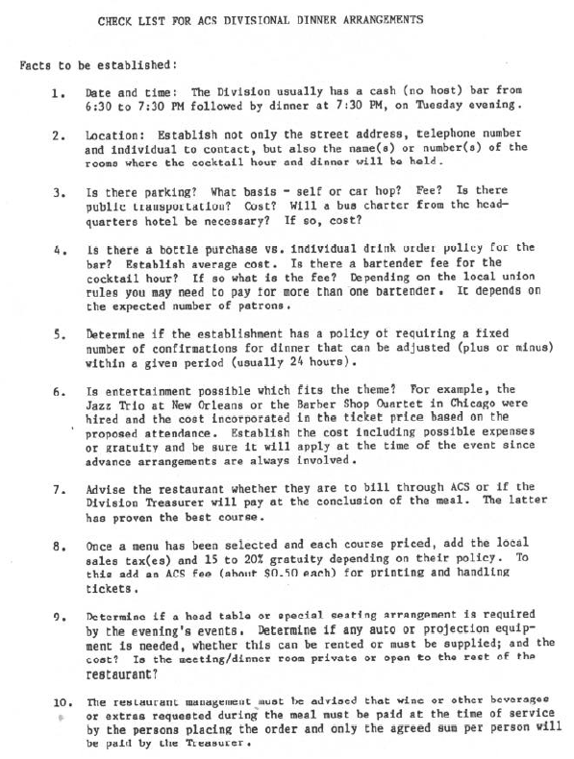
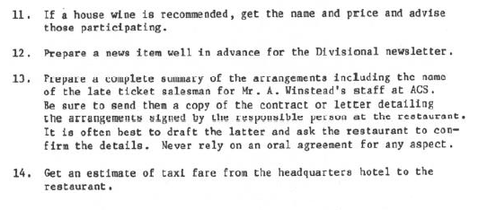
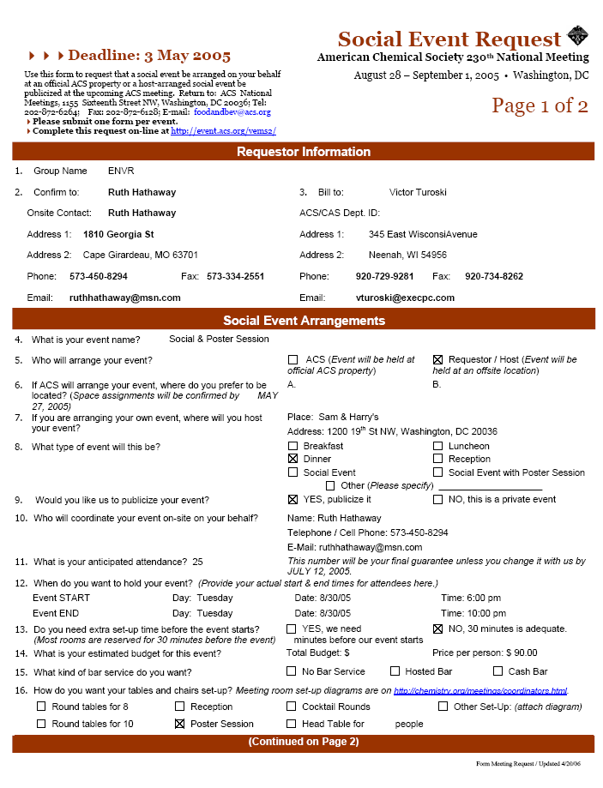
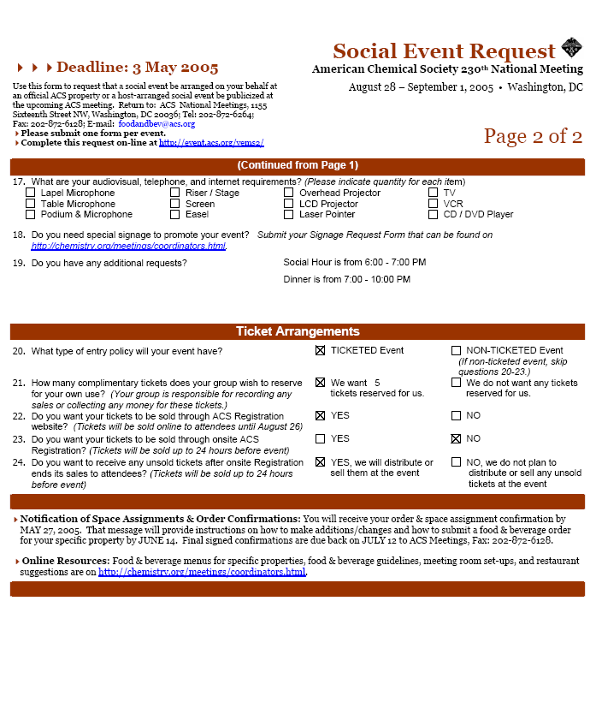

6024 Telegraph Rd.
Sample
Alexandria, VA 22310-2217
May 20, 1988

Kenneth Kim, Manager
Korean Gardens Restaurant
950 So. Vermont Ave.
Los Angeles, CA 90006

Dear Mr. Kim:

The Environmental Chemistry Division of the American Chemical Society would like to arrange a dinner at your restaurant, as we discussed by phone. The Society will be meeting with the International Congress in Toronto the week of September 25-30, 1988. The Division traditionally meets for dinner on Tuesday evening, which would be September 27.

The group convenes between 6:30 and 7:30 p.m. for a social gathering with a no-host cash bar. Dinner is served at 7:30 p.m. with a fixed menu and price that includes tax and gratuity. Tickets are printed in advance by ACS and are priced for the meal only. Wine or other orders by guests during the meal should be collected by the servers. If you have wine recommendations, these will be appreciated since there are usually a number of such purchases.

Our group usually numbers 50 to 75. We can arrange for a deposit. I would like to know whether you need a minimum guaranteed number of guests and whether 24 hours is sufficient for a final number of dinners. Full payment can be billed or paid after the meal by our Treasurer.

I look forward to your suggestions for a menu, and your letter confirming these arrangements.

Sincerely,

Anne R. Leslie
Social Arrangements Chair
Environmental Chemistry Division
American Chemical Society

Phone: 703/557-5077

KOREA GARDENS RESTAURANT, INC.
950 South Vermont Ave.. Los Angeles, Calif. 90006
Sample
Telephone (213) 388-3042

May 31, 1988

Anne R. Leslie
Social Arrangements Chair
Environmental Chemistry Division
American Chemical Society
6024 Telegraph Rd.
Alexandria, VA 22310-2217

Dear Ms. Leslie:

Thank you very much for your inquiry. We accept any group over 50 (over 40 in weekdays) & one day advance notification for final number of dinners would be sufficient. We carry a moderately priced California wine (Chablis & Rose) which is very popular among customers. A sample of suggested fixed menu would be like This:

1) Traditional Korean style short rib stew
2) Fillet fish dipped in egg butter & fried on hot griddle
3) Green bean Korean style pan cake
4) Sauteed vegetable with beef and vermicelli
5) Chicken drumstick with soysauce
6) Cold seafood special
7) Korean style pork chop
8) Squid with vegetable & hot pepper
9) Beef or pork tempra (fried in vegetable oil)
10) 1-3 Chef’s special in season
11) Variety of vegetables (5-10 kinds)
For example Kimchee (Korean style vegetable), Spicy cucumber, Cooked bean sprout, spinach

In conclusion, the fixed menu would be 10-13 main dishes and a lot of vegetables, steamed rice in buffet style. Its cost would be $14/person including tips & tax. We provide hot tea and coffee if anyone wants. But drinks are extra.

A deposit of $100 or more is required to reserve the banquet room and full payment is to be paid right after the party. If you have any more information, please let me know.

Sincerely,

Kenneth Kim
Manager
P.S. We have already reserved the room for your party on Sep 27

nor to complimentary exposition space

