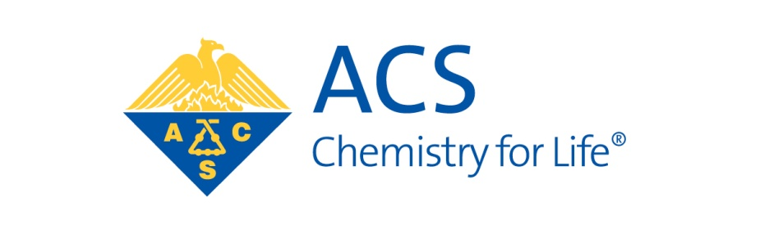

AMERICAN CHEMICAL SOCIETY
DIVISION OF ENVIRONMENTAL CHEMISTRY

Dear Colleague:

The Environmental Chemistry Division of the American Chemical Society is proud to offer competitive graduate student awards. The awards are designed to encourage and reward outstanding graduate students working towards degrees in environmental chemistry and engineering. Eligible students in these areas must have completed at least one year of graduate school and be enrolled in graduate school on February 1 during the same year as the application.

Please note, paper copies will no longer be accepted.

1. Environmental Chemistry Graduate Student Award. This award recognizes graduate students who are
working in areas related to environmental chemistry. The award is based on student transcripts,
record of research productivity, and a letter of recommendation from the faculty advisor. The awardees receive a monetary reward and an annual membership in the Environmental Division of the American Chemical Society. The awardees are publicized in EnvirofACS and Environmental Science and Technology. Up to 20 awards are given each year. The deadline for receipt of the completed application is October 31. Awards will be announced in January. Please distribute this information as widely as possible.

The announcement, eligibility requirements, and application form for Environmental Chemistry Graduate Student Award are included below. If you have questions please contact:

Kevin O’Shea
Chair, Student Awards Committee
Florida International University
T: (305) 348-3968
eMail: osheak@fiu.edu

GRADUATE STUDENT AWARDS IN
ENVIRONMENTAL CHEMISTRY

SPONSORED BY:

The American Chemical Society Division of Environmental Chemistry

BENEFITS TO AWARDEES

• One year membership in the Division

• Monetary Award

• Awardees will be publicized in Environmental Science and Technology and EnvirofACS

• Up to 20 awards will be made annually

ELIGIBILITY:

Open to all full-time graduate students (M.S. or Ph.D. candidates) currently enrolled at U.S. or international educational institutions in chemistry, environmental engineering, or other programs emphasizing environmental chemistry who have completed one full year of graduate study at their current institution. Must be enrolled as a graduate student on February 1 of the academic year in which the application is submitted. The student must be a member of the American Chemical Society and the student or advisor must be a member of the Division of Environmental Chemistry.

CRITERIA:

Award decisions will be based on student’s performance in course work, evidence of research productivity, and on statements from the faculty advisor. Primary emphasis will be given to the student’s potential for future contributions as professionals in environmental chemistry and engineering. Applications will come from the graduate student’s faculty advisors who may nominate only a single student.

APPLICATION MATERIALS:

Additional information on the application may be obtained from

Kevin O’Shea
Department of Chemistry and Biochemistry
Florida International University
T: (305) 348-3968
eMail: osheak@fiu.edu

The application will consist of a single pdf file submitted electronically to osheak@fiu.edu by the deadline. The single pdf should include (1) the attached application form, (2) a scanned copy of the student’s graduate transcripts, (3) a list of student publications, and (4) a letter of support from the student’s faculty advisor.

DEADLINE FOR RECEIPT OF APPLICATION:

October 31

