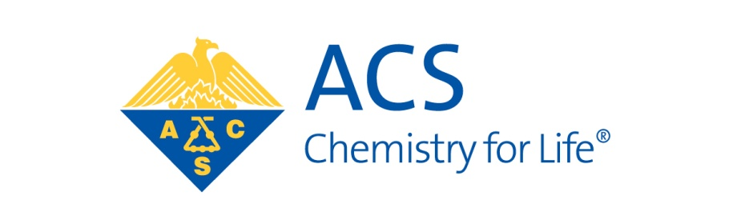

**AMERICAN CHEMICAL SOCIETY**

**DIVISION OF ENVIRONMENTAL CHEMISTRY**

Dear Colleague:

The Environmental Chemistry Division of the American Chemical Society offers competitive graduate student awards. The awards are designed to encourage and reward outstanding graduate students working towards degrees in environmental chemistry and engineering. Eligible students in those areas must have completed at least one year of graduate school and still be in graduate school on February 1 in the year of application deadline.

**Please note, paper copies will no longer be accepted.**

1. C. Ellen Gonter Environmental Chemistry Award. This award is presented to graduate students at U.S. and international universities who submit the highest quality research papers. This is a competitive award and submitted papers will be reviewed by the Awards Committee. The format to be followed is that of *Environmental Science and Technology*, except that the paper is limited to 15 pages total, including figures and references. Award winners are expected to present their papers at the Fall American Chemical Society National Meeting. Only those that present their papers will receive a $1,000 award at the Division of Environmental Chemistry fall social event. The deadline (receipt) for submission of a single pdf file via email to osheak@fiu.edu is **11:59 pm on December 31** annually (deadline may be extended by Awards Committee, announced by email to ENVR members). The winners will be announced in March. Up to 7 awards will be granted.

Additional information about the award is included. More details on the award can be obtained by contacting:

Kevin O’Shea

Chair, Student Awards Committee

Florida International University

T: (305) 348-3968

Email: osheak@fiu.edu

**C. ELLEN GONTER ENVIRONMENTAL CHEMISTRY AWARDS**

C. Ellen Gonter, born on February 28, 1922, graduated with a B.S. in Chemistry in 1952 from Carnegie-Mellon University. She worked for the U.S. Army during World War II, U.S. Steel Corp., was supervisor of analytical research for Pittsburgh Coke and Chemical Co., manager of the water division of the Nuclear Utilities Service Corp. of Pittsburgh and the National Sanitation Foundation of Ann Arbor, MI.  She was a certified professional chemist, chemical consultant, and an Emeritus member of the American Chemical Society.  C. Ellen Gonter served the Division of Environmental Chemistry extensively, as the Chair (1973), Secretary (1969-1971) and Treasurer (1976-1977).  Ellen attended nearly every national meeting and was a fixture at the Division table though-out her career.  She was instrumental in the development and establishment of the Graduate Student Research Paper award in 1985.  Due to her tireless volunteer efforts, the Division bestowed her with the Distinguished Service Award in 1979. C. Ellen Gonter was also a member of the American Institute of Chemists, the Society for Applied Spectroscopy, the International American Society for Testing and Materials for which she was secretary and member of the Board of Directors of the Pittsburgh section of the Society of Women Engineers.  The Division of Environmental Chemistry honored the memory and contributions of Dr. C. Ellen Gonter by renaming the Graduate Student Research Paper Award to the C. Ellen Gonter Environmental Chemistry Award in 2013.

AWARD DESCRIPTION

The Division of Environmental Chemistry is sponsoring graduate student research paper awards judged based on research and writing quality. Up to seven awards are granted each year consisting of a $1,000 cash award and a one-year membership in the Division of Environmental Chemistry. The awards will be presented at the Fall ACS National Meeting where the students will present their papers in an award symposium. **Only those students that present their papers will receive the $1,000 cash award.** All graduate students (M.S. or Ph.D.) enrolled full-time in chemistry, environmental engineering, or other programs emphasizing environmental chemistry and having completed one year of graduate study are eligible. The research paper must be relevant to environmental chemistry, the student must be the first and major author, and the work must have been done while attending the student’s current institution. The paper may have been submitted to a journal at the time of submission, but it should not have already been published or presented at another meeting. A major advisor may nominate only a single student. Either the student or the major advisor must be a member of the Division of Environmental Chemistry.

To apply for the award, a graduate student must submit the following:

1. The full paper, **limited to 15 pages** double-spaced, including the references and figures as a

single pdf file. The cover page (not counted against the 15-page limit) should include the following:

a. The student’s campus and permanent address, email, and phone number.

b. Major advisor’s name, address, email, and phone number.

c. The student’s current enrollment (institution, department degree program, and expected

completion date).

d. Statement by the advisor that the research and writing is predominantly that of the

student.

The papers will be judged by the Student Awards Committee of the Division of Environmental Chemistry. Awards will be announced in March. An ACS Abstract submitted to <http://maps.acs.org> will be required of those students who win the awards.

We request that faculty advisors encourage graduate students in their respective departments to participate in the competition. The award is the highest honor granted by the Division of Environmental Chemistry for students. Further information can be obtained from Kevin O’Shea at (305) 348-3968 (Email: osheak@fiu.edu).

Submit the paper and accompanying information via email by the **December 31** deadline (**receipt**) to:

Kevin O’Shea

Department of Chemistry and Biochemistry

Florida International University

Email: osheak@fiu.edu